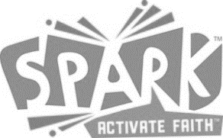

SPARK Sunday School Registration
2022-2023

Child’s Name Age Birth Date Grade

Mailing Address

Parent/Guardian 1 Parent/Guardian 2
Relationship Relationship
Cell Phone Cell Phone
Email Email

EMERGENCY CONTACT Relationship CELL PHONE

Please list names(s) of person(s) that may pick up your child BESIDES those listed above.

MEDICAL

Please list all allergies, medical conditions, or other concerns:
Does this child have an Epi-Pen? YES ☐ No ☐

Church history
Has your child attended another church? If so where?

Was your child Baptized? | Yes ☐ | No ☐ | Where? |  | Date:

MEDIA USE

I give my permission to use my child’s picture:
In church or in class projects: Yes ☐ No ☐ In advertising (Facebook, etc.): Yes ☐ No ☒

Parent/Guardian Signature Date

